

Your organization’s opportunities in communications, content, and technology have never been greater, nor have the complexity of evolving technologies and marketplaces been more involved and challenging than at this time. Success in today’s fast moving world depends on timely, targeted information and actionable insights. Are you making plans and decisions based on the best available research and intelligence about your competitors and customers? Do you need quality analysis and insights to size and target markets, manage risks, understand emerging trends, and anticipate competitors’ strategies and actions? International Research Center (IRC) has provided consulting, custom research, and strategic support for business, legal, and public policy clients in a variety of high-technology disciplines and arenas since 1992. We can provide market-driven insights to help you track and forecast market trends, assess strategic options, and optimize your results.

IRC concentrates on clients’ needs in the complex worlds of telecommunications, information technology, eContent, eLearning, the Internet, biotechnology, and other domains by harnessing global information resources for informed decision making. Our principals combine extensive experience in market research and trending, as well as core competencies in industries and markets, intelligence acquisition, incisive analysis, and strategic planning. Additionally, IRC utilizes a broad base of specialists and consultants, exploiting global networked communication to address our client’s varied research needs with complete confidentiality and superlative results. IRC will gather and evaluate relevant primary and secondary information, prepare and deliver concise and targeted results, and provide cost effective and timely solutions to your critical information needs.

Market Research and Intelligence:

- Business and Competitive Intelligence
- Market Research Collection and Analysis
- Survey Development and Execution
- Strategic Landscape Mapping and Analysis
- Strategic Planning Support and Facilitation
- Business Development (BizDev) Support
- Strategic Partner and Prospect Identification
- Mergers and Acquisitions Due Diligence
- IT, Technology and Content Assessment, Productization and Commercialization
- Tracking Innovations and R&D in Industry, Science and Technology, White Papers
- Industry, Economic and Political Trends - Regional, National and International Scope
- International Development and Trade
- Political Climate, Travel and Relocation
Legal and Public Policy Support:

- Public Policy Studies and Surveys
- Stakeholder Engagement, Strategic Facilitation and Consensus Building
- Government Legislation and Regulation
- Energy and Environmental Issues
- Claims and Litigation Support Research
- Expert Witness Identification and Verification
- Intellectual Property (IP) Copyright, Domain Name, Trademark and Patent Support

Research, Analysis and Education:

- Background on Issues and Events
- Current Awareness Alerts and Services
- Custom In-House Keynotes & Presentations
- Customized Training in Internet, Telecom, Research Skills and Strategic Technologies

Please contact us concerning your specific information and research needs:

International Research Center
PO Box 825, Tempe, AZ 85280-0825 USA, Voice & Fax: (602) 470-0389
E-mail: irc@researchedge.com, URL: http://www.researchedge.com/ (06/06)

Why International Research Center?

• Partnering:
Experienced and successful at contributing to team efforts led by clients or partners or leading integrated teams to timely project deliverables and ultimate success

• Public and Private:
Experience in working for and with both public and private enterprises, as well as creating public-private partnerships

• Relationships:
Knowledge, access, and credibility with government, various industry sectors, leading experts and key stakeholders

• Research Expertise:
Strong primary and secondary research knowledge, skills and resources allowing us to offer a “best-of-breed” research team with a proven track record

• Technological Expertise:
Substantial Telecommunications, Information Technology (IT), Internet, eCommerce, and eContent experience

• Objectivity:
Unbiased comprehensive identification and assessment of enterprise and stakeholder needs, available data and options

• Flexibility and Creativity:
Sensitive to evolving trends and enterprise needs to help provide a far-seeing outlook and “future-proof” options

• Track Record:
Successful completion of hundreds of industry and public policy projects over ten years on time, within budget, and to the delight of our clients!

• IRC Principals:
Mark Goldstein is President of International Research Center and leads a diverse and talented team in consulting, custom research, and strategic projects. Mark is a technophile and technology visionary, activist, advisor, and entrepreneur with extensive experience and connections throughout numerous technology sectors.
Examples from IRC Projects

Telecom Connectivity Overview

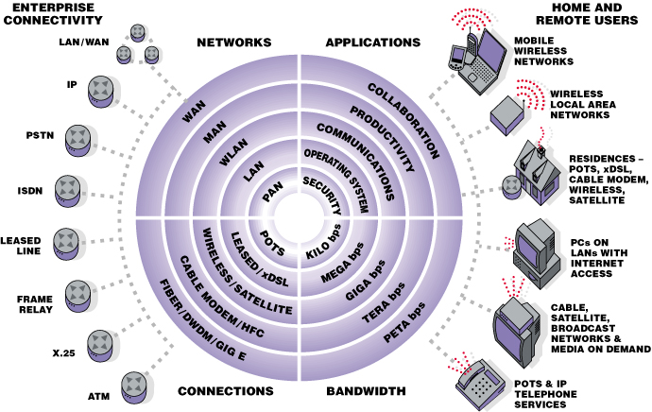

Content Value Chain Model

Research Portal Information Architecture

